# **The Battle of the Neighbourhoods**

1. **Introduction and business Problem** 
   1. **Problem Background:**

The City of Manchester is the second biggest city in the United Kingdom. It is:

* A multicultural and multi-ethnic populated city.
* Second most peoples from Asia are leaving in this city.
* Famous for the different business operations and official hub.
* Various businesses are playing in the market in Manchester.
* The city is a significant centre for retailing, world trade, transportation, tourism, real estate, media, advertising, legal services, accountancy, insurance, fashion, and the arts in the United Kingdom.

This also means that the market is highly competitive. As it is a highly developed city, so the cost of doing business is also one of the highest. Thus, any new business venture or expansion needs to be analysed carefully. The insights derived from the analysis will give a good understanding of the business environment, which helps in strategically targeting the market. This will help in the reduction of risk. And the Return on Investment will be reasonable.

* 1. **Problem Description:**

There are lot of Asian business are operating in this city, A restaurant is one of the business mostly India restaurants which prepares and serves food and drink to customers. It also offers the takeaway and homedelivery services. Most of British peoples are like India cuisine, and busiest time is weekends and holidays. The main challenge is there a lot of Indian restaurant but few of them are genuine. Generally, peoples are searching Indian restaurant with different factors like

1. Restaurants should have maintained hygric.
2. It should have serving some British cuisine, like chips.
3. Free home deliver with less minimum ordering cap.
4. Neared to bus stop and easily accessible.
5. Good hospitality.
6. The foods are prepared from halal.

So, it is evident that to survive in this competitive market it is very important to strategically plan. Various factors need to be studied in order to decide on the Location such as:

1. Asian Population
2. Manchester Demographics
3. In which area of the city mostly Asians live?
4. Are there any bus or metro stop nearby?
5. Who are the competitors in that location?
6. Menu of the competitors.
7. Any gathering places nearby?
8. How soon people can come to know about this restaurant.
9. Franchise of restaurant if any.  
   The list can go on...

Even though well-funded Company need to choose the correct location to start its first venture.

* 1. **Target Audience:**

The owner of the restaurant and its management.

This would interest anyone who wants to start a new restaurant in Manchester city.

* 1. **Success Criteria:**

The success criteria of the project will be a good recommendation of location choice to start the restaurant with successful business.

1. **Data Collection** 
   1. **Data source 1: Getting Manchester postal codes**

On this problem the only data will be analysed on the city map of Manchester, which can be found from wiki page <https://en.wikipedia.org/wiki/M_postcode_area>. from this page:

* Scarp the postcode district, local authority and coverage area.
* Create a data frame from this data.
* Using foursquare, cluster the various location of Indian restaurant.
* Identify where large number of restaurants is present.
* Identify the bus stops, metro stops on that area.
* Identify any public events places nearby.
* Any nearest Indian grocery shop for easy purchase of the raw materials.
* Identify home delivery areas.
  1. **Data source 2: Manchester longitude and latitude co-ordinates.**

The co-ordinates of Manchester city postcodes can be downloaded from below link. https://raw.githubusercontent.com/binodpanda/github-example/master/manchester_uk_cordinates.csv

* 1. **Data Cleaning**

Some postal codes have multiple records based on sectors as show below. Here M3 have two records.

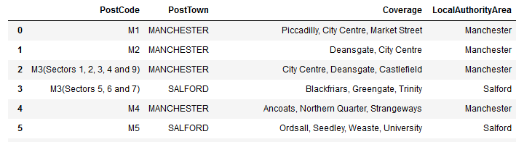

It is required to clean-up the data by removing extra the information from the post code. To achieve this, it is required to split the string with first occurrence of ‘(‘character. (We are not bothered about local authority area). After removing this the data set will be

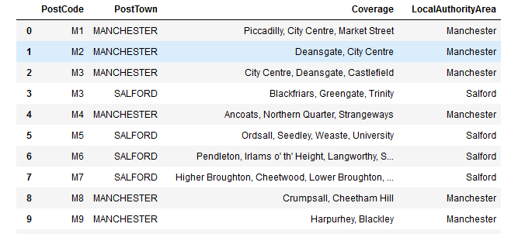

Second, we need to import the Manchester co-ordinates file and the merge to the above dataset.

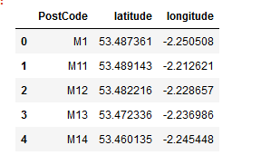

After merging the dataset will be as follows

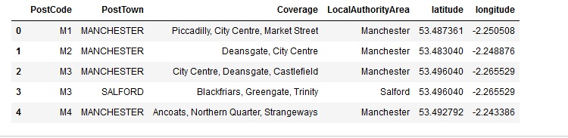

1. **Exploratory Data Analysis**
   1. **Calculation of target variable**

Out target value is to identify the area where most of the Indian restaurants are present. To identify it we must explore the Manchester city map and identify the venues. Before that it is too required to get the details of latitude and longitude. This will help on clustering the records. Create map of Manchester using latitude and longitude values.

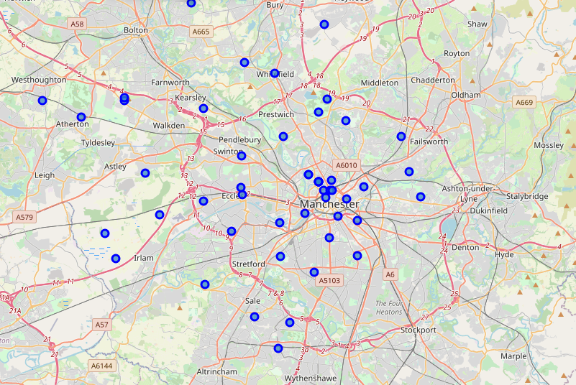

This show the area of Manchester of different post codes around the city. Each city has different venues and different interesting points. We will use foursquare to get the details of the venues across of Manchester. This list will tell in which post code or neighbourhood what type of venue is present and how many. The summary of data will be,

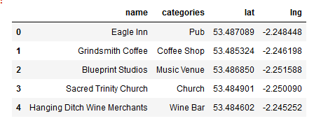

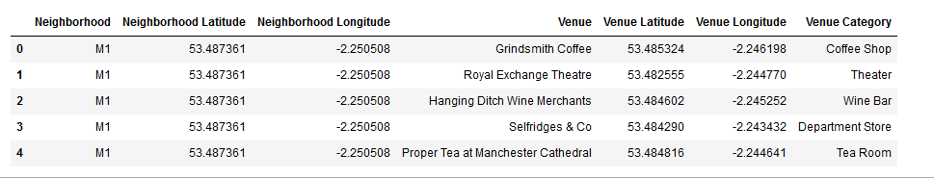

However, we only interested on getting Indian restaurants, for that using pandas method we can filter out the venues only for Indian restaurants. Once we filtered find the number of restaurants in each post code area, ignore the post codes where there is no Indian restaurants present. For better understanding we will convert this to bar chart.

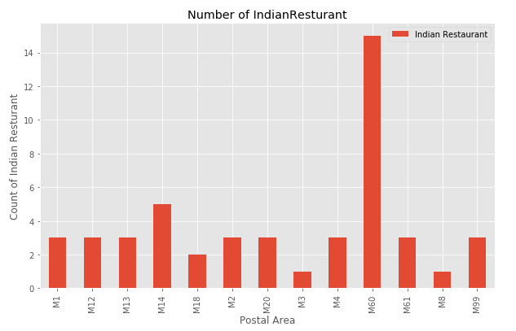

The above graph shows that M60 have the highest number of the restaurant and it represents that M60 is suitable for competitive Indian restaurants.

1. **Conclusion**

Based on the analysis of the analysis of Manchester data it has concluded that it is good place to open the restaurants for the competitive as it can shows the market sharing high in this place.

1. **Future directions**

The second highest area is M14 where Indian restaurants are growing than other areas. It is also advisable to open an branch of the restaurant in this area in future.